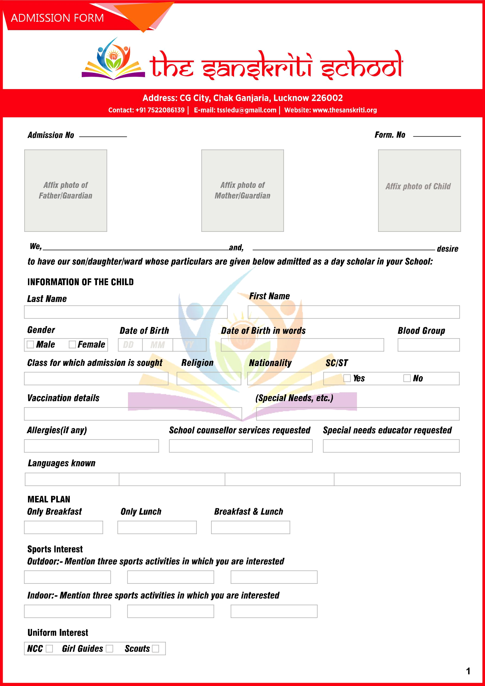
Contact : +91-7522086139 | E-mail : contact@thesanskriti.edu.in | Website : www.thesanskriti.edu.in
